**App Name:**

BU Events Planner

**App Purpose:**

BU Events Planner is designed for Boston University students to easily browse and register for various campus events. The app aims to help students stay informed about campus happenings, providing an accessible way to enhance their university experience by participating in events.

**Main Features:**

1. User Registration and Login: Users can register and log in using their email or through third-party platforms like Google.
2. Event List Browsing: Users can view a list of upcoming events, with details such as date, time, and location.
3. Event Details View: By selecting an event, users can see more detailed information, including descriptions, timings, location, and an option to register for the event.
4. Personal Homepage with Event History: Users can view a personal profile page displaying past attended events and upcoming registered events, categorized by time.

**Target User:**

Primarily designed for Boston University students and staff who want quick access to information about campus events.

**Technical Specifications:**

1. **Tech Stack:**

Programming Language: Kotlin

UI Framework: Jetpack Compose

Database: Firebase Firestore (for storing and syncing user data)

Authentication Service: Firebase Authentication (supports email login and Google Sign-In)

Network Requests: Retrofit (for accessing event data from third-party APIs)

1. **APIs and Data Sources:**

Firebase Firestore: To store event details and user registration history.

Firebase Authentication: For user registration and login.

Third-Party API: Optionally, a public event data API could be integrated to supplement campus event information.

1. **External Libraries and Tools:**

Firebase Crashlytics: For real-time error and crash monitoring.

Glide or Coil: To load and display event images smoothly.

**Milestones:**

1. **Proposal Submission:**

Submit a document outlining the app's purpose, main features, techniques may use, target audience and initial mockups created with Figma, covering the primary pages.

1. **Feature Development:**

* Implement user authentication with Firebase Authentication.
* Complete core functionality for event list and event details pages.
* Develop the user interface with Jetpack Compose, following Material Design standards.

1. **Testing and Optimization:**

Write unit tests and UI tests to ensure core functionality works as expected.

1. **Final Submission:**

Upload to GitHub and demonstrate the app’s main features.

1. **Final Presentation:**

Present the final report and demonstration.

**Mockups and UI Design:**

1. Event List Page:

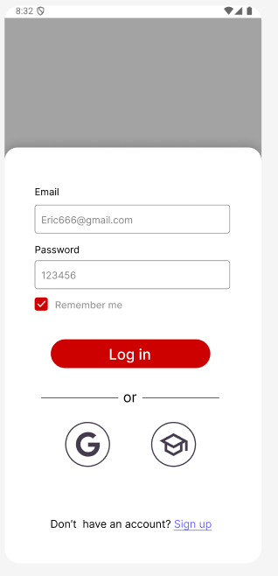

1. Event List:

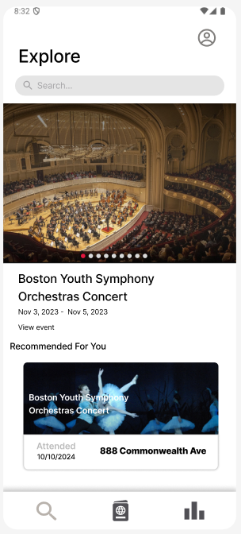

1. Signle Event Page:

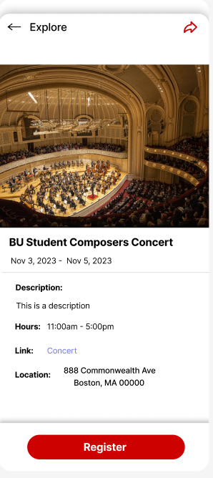

1. User’s Personal Homepage:

